Desmos Lesson: Linear Regression

Vocab words to know:

Linear Regression: Attempts to model the relationship between a dependent and an independent variable by fitting a linear equation to observed data.
Residual: The difference between the observed value of the dependent variable and the predicted value.
Correlation Coefficient: a number between -1 and +1 calculated so as to represent the linear dependence of two variables or two sets of data. +/-.8-1= strong correlation, +/-.5-.8= moderate correlation, +/-0-.5= weak correlation.

Data set: Today we will be looking at the height and weight of the New York Yankees 25-man roster from 2019 and determining if there is a strong, moderate, or weak correlation between height and weight of the players.

Height (inches) | Weight (Pounds) | Height (inches) | Weight (pounds) | Height (inches) | Weight (pounds)
73 | 235 | 72 | 225 | 75 | 205
75 | 215 | 74 | 230 | 77 | 205
74 | 215 | 78 | 245 | 75 | 195
76 | 235 | 74 | 220 | 75 | 210
77 | 220 | 73 | 200 | 73 | 230
73 | 205 | 72 | 220 | 78 | 300
79 | 282 | 75 | 225 | 80 | 265
71 | 195 | 72 | 210
76 | 215 | 76 | 212

- Create a table on Desmos and input the data. 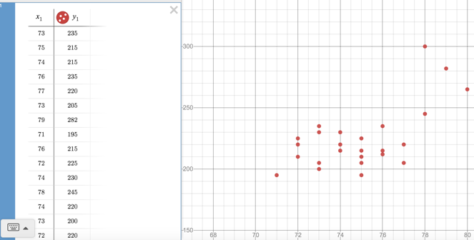
- Create the line of regression. To do this, click “add item”, and select f(x) expression. Type “$y_{1}\sim mx_{1}+b$”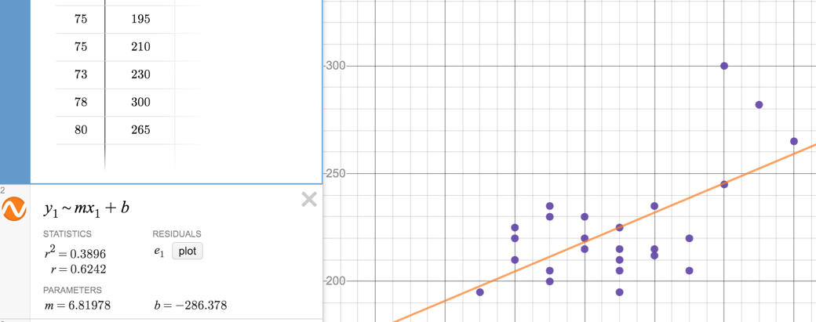
- Desmos has calculated the correlation coefficient (r) to be 0.6242. Is this correlation strong, moderate, or weak? Is the correlation positive or negative?

- Desmos has calculated the slope of the line to be m=6.81978 and the y-intercept to be b=-286.378. What is the equation for the line?

- Plot the residuals. To do this, click “$e_{1}$ plot”. The residuals will be plotted on the graph and be added to the existing table. 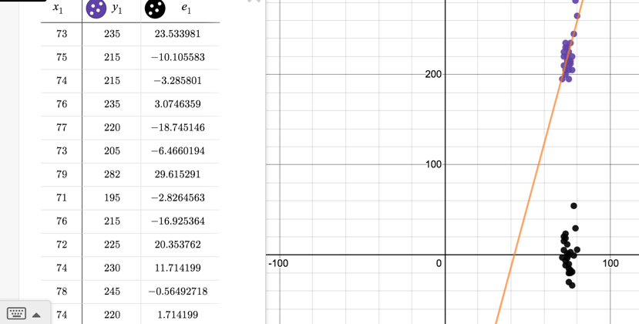

Which observed value is closest to its predicted value?
Which observed value is farthest away from its predicted value?

- Click “add item” and select f(x) expression. Type the equation of the line. Click “edit list” and “convert to table”. Now we can make predictions about the weight of any new players added to the team based on their weight. 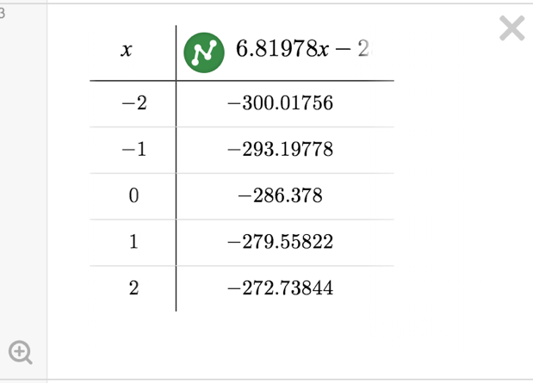
If the Yankees acquire a player who is 66 inches tall how much can we predict he weighs?

If the Yankees acquire a player who is 73 inches tall how much can we predict he weighs?

If the Yankees acquire a player who is 69.5 inches tall how much can we predict he weighs?

Sources:
https://www.youtube.com/watch?v=zcZaI-xfiFE
https://stattrek.com/statistics/dictionary.aspx?definition=residual
http://www.stat.yale.edu/Courses/1997-98/101/linreg.htm

