Game Theory
What is Game Theory?
Game theory is a branch of applied mathematics that provides tools for analyzing situations in which parties make decisions that are interdependent. A solution to the game describes the optimal decisions of the players and the outcomes that result from their different decisions.

Key Terms

Game- a set of circumstances that has a result dependent on the actions of two or more players
Players- a strategic decision-maker within the context of the game
Strategy- a complete plan of action that a player will take given the set of circumstances that may arise within the game
Payoff- the payout a player receives for arriving at a particular outcome
Information set- information available at a given point in the game
Equilibrium- the point in the game where both players have made their decisions and an outcome is reached.

Types of Games

- Cooperative and non-cooperative
- Normal form and extensive form
- Simultaneous move games and sequential move games
- Constant sum, zero sum, non-zero sum
- Symmetric and asymmetric

The Prisoner’s Dilemma

Two criminals are arrested for a crime and are interrogated separately. There is not enough evidence to convict the two criminals. The two criminals are unable to communicate with each other and are both presented with four different outcomes.
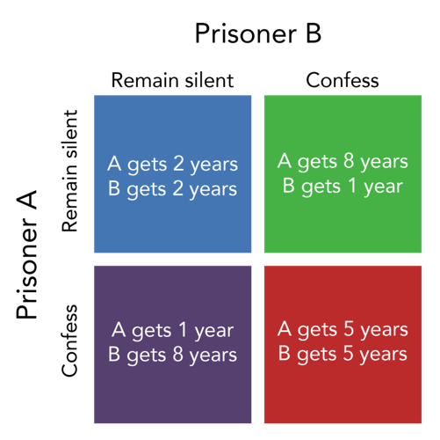
Which option is the best for both prisoners? _______________
Which option is most likely outcome and why? ____________________________________ _____________________________________________________________________________
Cartel as A Prisoner’s Dilemma
Venezuela and Nigeria have created an oil cartel. If they cooperate, the potential profit is $10 million dollars, evenly divided. If they both cheat the maximum profit is only $8 million dollars.

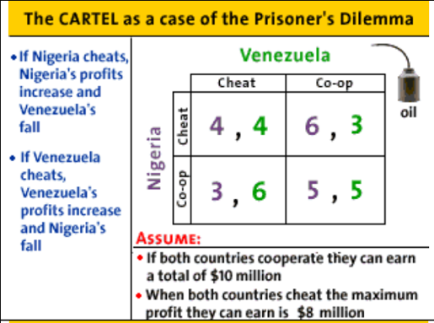
Which option is the best for both countries? _______________
Which option is the most likely outcome and why? ____________________________________ _____________________________________________________________________________
Coke vs. Pepsi
Coca-Cola is considering cutting the price of its soda. Pepsi may have no choice but to do the same in order to retain its market share. If both companies keep prices high, profits will increase by $500 million dollars. If one company drops prices they will increase profits by $750 million dollars while the other company’s profits will remain unchanged. If both companies’ lower prices, profits will increase by $250 million dollars for both.

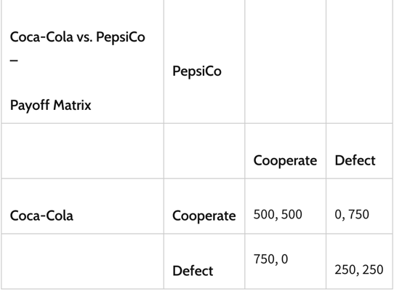
Which option is the best for both companies’? _______________
Which option is the most likely outcome and why? ____________________________________ _____________________________________________________________________________

